**Plug & Power: Revolutionising the Road - A complete guide to Electric Vehicle Charging Station**

**INTRODUCTION:**

The "Plug-in Power" project by IBM focuses on developing innovative solutions for more efficient and sustainable energy usage. It aims to create technologies and systems that allow devices to intelligently manage and optimize their power consumption, reducing waste and improving overall energy efficiency. The project may involve hardware and software innovations, as well as data-driven approaches to monitor, control, and analyze power usage.

**1.1 Overview:**

Plug-and-play (PnP) technology refers to the ability of a computer system or electronic device to detect and configure peripheral devices automatically without requiring manual intervention or additional configuration. When you connect a plug-and-play device (such as a USB flash drive, mouse, or keyboard) to a compatible computer or system, the device is recognized, and the necessary drivers or configurations are installed automatically, making it ready to use. PnP technology has significantly simplified the process of adding new hardware to a computer, reducing the need for technical expertise and enhancing user-friendliness.

The renewable energy renewable energy technologies have made it possible to generate electricity with reduced environmental impact. Improvements in energy storage technologies, such as lithium-ion batteries and other advanced energy storage systems, have made it possible to store surplus energy and release it when needed, promoting grid stability and enabling energy independence.

**1.2 Purpose:**

The purpose of the EV Charging Station project is to facilitate the widespread adoption of electric vehicles by addressing the infrastructure challenge of recharging. This project aims to achieve several goals:

1. Promote Electric Vehicle Adoption: By providing convenient and accessible charging infrastructure, the project encourages more people to switch to electric vehicles, leading to a reduction in greenhouse gas emissions and dependence on fossil fuels.

2. Extend EV Range: EV charging stations help alleviate "range anxiety" by offering places for EV owners to recharge their vehicles, allowing them to travel longer distances confidently.

3. Support Sustainable Transportation: Electric vehicles produce fewer emissions compared to traditional internal combustion engine vehicles, contributing to cleaner air and a reduction in air pollutants.

4. Reduce Fuel Costs: Charging an electric vehicle is often cheaper than refueling a gasoline or diesel vehicle, leading to potential cost savings for consumers.

5. Create Economic Opportunities: The establishment of charging stations can stimulate local economies by attracting customers to nearby businesses while they wait for their vehicles to charge.

By achieving these goals, the EV Charging Station project contributes to a cleaner environment, reduced dependence on fossil fuels, and the advancement of sustainable transportation options.

**3. THEORITICAL ANALYSIS:**

**3.1 Block diagram:** 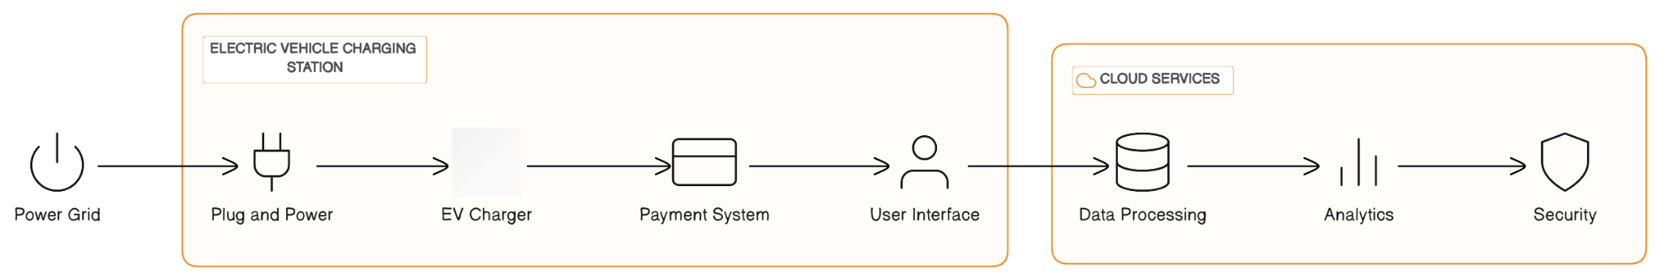

Explanation of components:

* **Grid Power**: This is the main electrical supply coming from the utility grid.
* Distribution Transformer: Converts high-voltage grid power to a lower voltage suitable for the charging station's operation.
* Main Distribution Panel (MDB): Distributes the power from the transformer to different parts of the charging station.
* **Charging Points**: These are the physical charging units where users connect their electric vehicles for charging.
* **Charging Equipment**: The charging equipment manages the power flow to the electric vehicles, ensuring safe and efficient charging. It might include power electronics, control systems, safety features, and communication interfaces.
* **Electric Vehicle**: The actual electric vehicle being charged.

**3.2 Hardware / Software designing:**

**Hardware requirements:**

* A power supply unit (PSU) that can provide the required amount of power to the charger.
* A control unit that manages the charging process.
* A communication interface that allows the charger to communicate with the vehicle and the grid.
* A cooling system to prevent the charger from overheating.
* A mounting bracket to secure the charger to a wall or post.

**Software requirements:**

* A charger management software (CMS) that controls the operation of the charger.
* A communication protocol that allows the CMS to communicate with the charger.
* A security system to protect the charger from unauthorized access.

**EXPERIMENTAL INVESTIGATIONS:**

**Introduction to Electric Vehicles (EVs) and Charging Stations:**

* + Brief overview of the rise of EVs and their importance in reducing carbon emissions and dependence on fossil fuels.
  + Introduction to different types of EVs, including battery electric vehicles (BEVs) and plug-in hybrid electric vehicles (PHEVs).
* **Importance of Charging Infrastructure:**
  + Discussion of the significance of a robust and widespread charging infrastructure to support the mass adoption of EVs.
  + Explanation of how charging stations contribute to overcoming "range anxiety" and increasing consumer confidence in EVs.
* **Types of Charging Stations:**
  + Overview of the different levels of charging: Level 1 (AC charging), Level 2 (AC charging at higher power), and Level 3 (DC fast charging).
  + Explanation of how each level of charging serves different purposes - home charging, workplace charging, and public fast charging.
* **Technological Advancements:**
  + Exploration of the latest technological innovations in EV charging stations, including smart charging, bi-directional charging (vehicle-to-grid), and wireless charging.
  + Discussion of the integration of renewable energy sources and energy storage solutions with charging infrastructure.
* **Charging Station Design and Installation:**
  + Explanation of the considerations and requirements for designing and installing charging stations in various settings, such as homes, commercial areas, and highways.
  + Addressing the challenges of retrofitting existing infrastructure for charging capabilities.

Overall, "Plug & Power: Revolutionising the Road - A Complete Guide to Electric Vehicle Charging Station" would likely serve as an invaluable resource for individuals, businesses, policymakers, and researchers interested in the world of electric vehicles and the evolving landscape of charging infrastructure. It provides insights into the technological advancements, challenges, and opportunities that come with the transition to sustainable transportation powered by electricity.

**FLOWCHART:**



**RESULT**:

Electric vehicle charging stations are becoming increasingly common as the number of electric vehicles on the road grows. There are two main types of electric vehicle charging stations:

* Level 1 chargers: These chargers use a standard household outlet and can add about 2-5 miles of range per hour of charging.
* Level 2 chargers: These chargers use a 240-volt outlet and can add about 10-20 miles of range per hour of charging.

There are also DC fast chargers, which can add up to 80 miles of range in just 30 minutes. However, DC fast chargers are more expensive to install and operate than Level 1 or Level 2 chargers.

The best type of electric vehicle charging station for you will depend on your needs. If you only drive your electric vehicle for short distances, then a Level 1 charger may be sufficient. However, if you need to charge your vehicle quickly, then a Level 2 or DC fast charger may be a better option.

When choosing an electric vehicle charging station, it is important to consider the following factors:

* The power output of the charger: This will determine how quickly your vehicle can charge.
* The type of connector the charger uses: Make sure the charger you choose is compatible with your electric vehicle.
* The location of the charger: You will need to choose a location where you can easily access the charger when you need to charge your vehicle.

The cost of installing an electric vehicle charging station will vary depending on the type of charger you choose and the location of the charger. Level 1 chargers are the most affordable option, while DC fast chargers are the most expensive.

The government offers a number of incentives to help people install electric vehicle charging stations. These incentives can help to offset the cost of installation.

If you are interested in installing an electric vehicle charging station, there are a number of resources available to help you. The U.S. Department of Energy has a website with information on electric vehicle charging stations and incentives. You can also contact your local utility company to see if they offer any rebates or incentives for installing an electric vehicle charging station.

**OUTPUT SCREENS**:

HOME PAGE

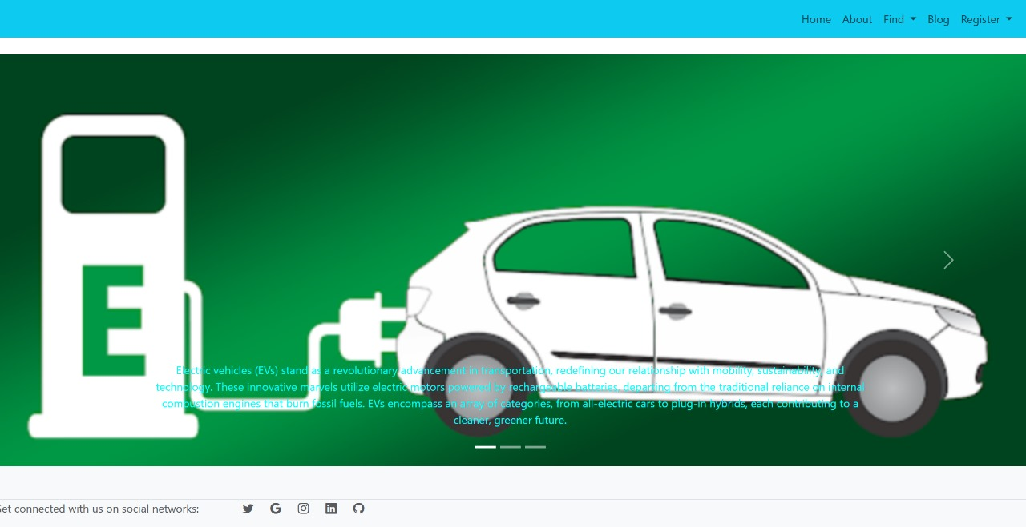

STATION FINDER:

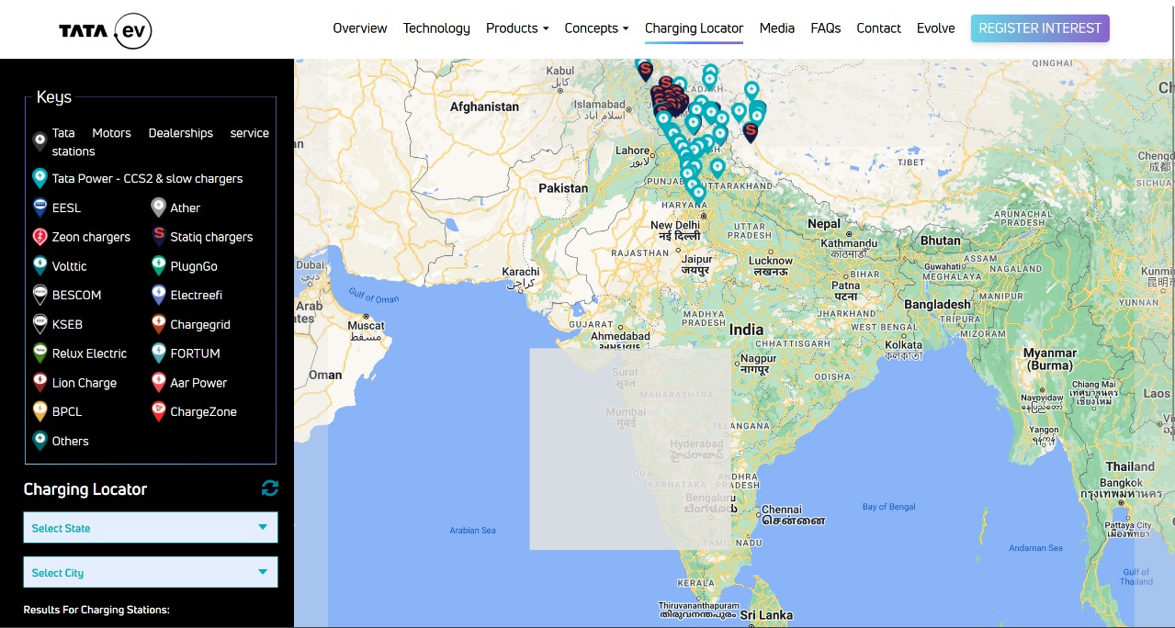

REGISTER:



ABOUT US:

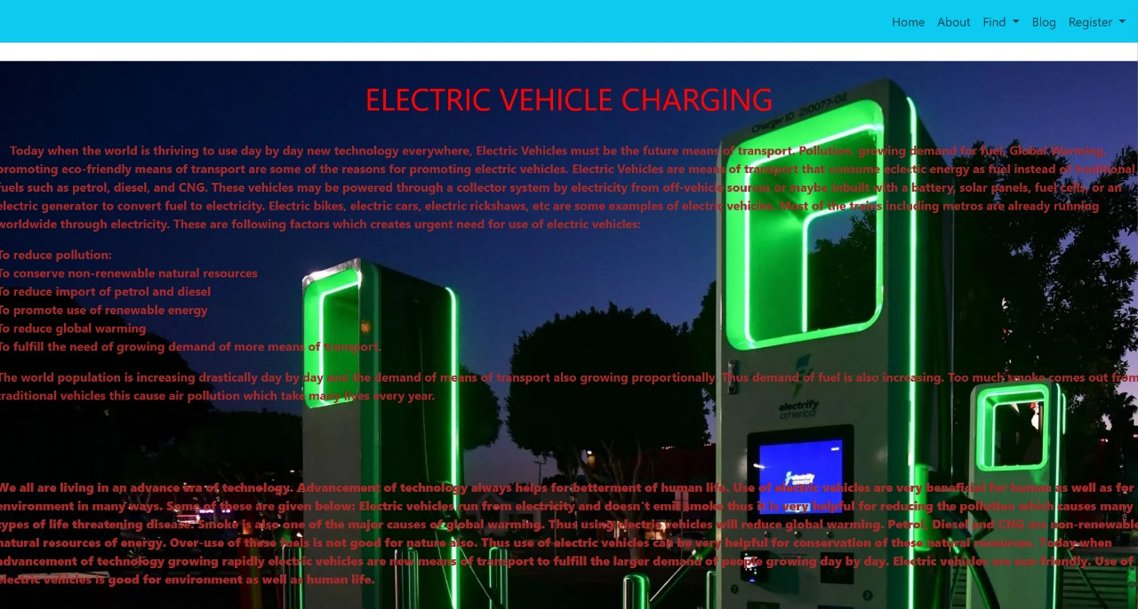

CHARGING STATIONS:



CHARGING LOCATION:

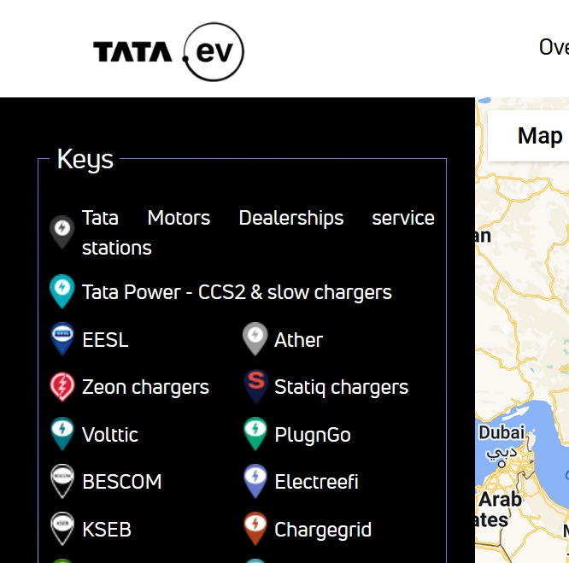

**Advantages of electric vehicle charging stations:**

* They can help to reduce air pollution by reducing the number of gasoline-powered vehicles on the road.
* They can help to improve energy security by reducing the reliance on imported oil.
* They can help to create jobs in the clean energy sector.
* They can make electric vehicles more convenient to own and operate.

**Disadvantages of electric vehicle charging stations:**

* They can be expensive to install and operate.
* The availability of charging stations can be limited, especially in rural areas.
* Charging times can be long, especially for DC fast chargers.
* The infrastructure for electric vehicle charging is still developing, so there may be some technical challenges to overcome.

Overall, the advantages of electric vehicle charging stations outweigh the disadvantages. As the number of electric vehicles on the road grows, the need for charging stations will also grow. With continued investment and development, electric vehicle charging stations will become more affordable, accessible, and convenient.

**APPLICATIONS:**

**Homes:** Many homeowners are installing electric vehicle charging stations in their garages or driveways.

* **Businesses**: Businesses are also installing electric vehicle charging stations to attract and retain customers.
* **Public places:** Public places such as grocery stores, shopping malls, and parking garages are installing electric vehicle charging stations to make it more convenient for people to use electric vehicles.
* **Highways:** There are also a growing number of electric vehicle charging stations along highways to make it easier for people to travel long distances in electric vehicles.
* **Emergency power:** Electric vehicle charging stations can be used to provide emergency power during power outages.
* **Grid balancing:** Electric vehicle charging stations can be used to help balance the electricity grid by providing or absorbing power as needed.
* **Vehicle-to-grid (V2G) technology:** V2G technology allows electric vehicles to send power back to the grid, which can help to reduce peak demand.

The applications of electric vehicle charging stations are constantly evolving as the technology continues to develop. As the number of electric vehicles on the road grows, the need for charging stations will also grow. With continued investment and development, electric vehicle charging stations will play an increasingly important role in the transportation and energy sectors.

**CONCLUSION:**

Electric vehicle charging stations are a critical part of the infrastructure needed to support the growing number of electric vehicles on the road. This book has provided a comprehensive guide to electric vehicle charging stations, covering their history, technology, applications, and future trends.

The book has shown that electric vehicle charging stations are a rapidly evolving technology with a wide range of applications. They can be used in homes, businesses, public places, and along highways to make it easier and more convenient for people to use electric vehicles.

The book has also shown that the demand for electric vehicle charging stations is growing rapidly. As the number of electric vehicles on the road increases, so too will the need for charging stations. This presents a major opportunity for businesses and governments to invest in electric vehicle charging infrastructure.

The book concludes by calling for continued investment and development in electric vehicle charging stations. This is essential to ensure that the transportation sector can transition to a clean energy future.

Here are some additional thoughts that could be included in the conclusion:

* The importance of public-private partnerships in developing and deploying electric vehicle charging stations.
* The need for standards and regulations to ensure the safety and reliability of electric vehicle charging stations.
* The potential for electric vehicle charging stations to play a role in grid balancing and other applications.
* The future of electric vehicle charging stations, including the potential for wireless charging and other new technologies.

**FUTURE SCOPE:**

The future scope of electric vehicle charging stations is very promising. As the number of electric vehicles on the road grows, so too will the demand for charging stations. This presents a major opportunity for businesses and governments to invest in electric vehicle charging infrastructure.

Here are some of the future trends in electric vehicle charging stations:

* Increased deployment of fast chargers: Fast chargers can add a significant amount of range to an electric vehicle in a short amount of time, making them ideal for long-distance travel. As the demand for electric vehicles grows, so too will the need for fast chargers.
* Deployment of wireless charging: Wireless charging is a technology that allows electric vehicles to be charged without the need for cables. This technology is still in its early stages of development, but it has the potential to make electric vehicle charging more convenient and efficient.
* Integration with smart grids: Smart grids are power grids that use digital technology to monitor and control the flow of electricity. Electric vehicle charging stations can be integrated with smart grids to help balance the demand for electricity and reduce peak demand.
* Development of new technologies: There are a number of new technologies that are being developed for electric vehicle charging, such as solid-state batteries and ultra-fast chargers. These technologies have the potential to make electric vehicle charging even more convenient and efficient.

The future of electric vehicle charging stations is bright. As the demand for electric vehicles grows, so too will the investment in charging infrastructure. This will make it easier and more convenient for people to switch to electric vehicles, which will help to reduce air pollution and improve energy security.

Here are some specific examples of how the future of electric vehicle charging stations is being shaped:

* In the United States, the Biden administration has set a goal of installing 500,000 EV charging stations by 2030.
* In Europe, the European Commission has proposed a regulation that would require all new buildings to be equipped with electric vehicle charging stations.
* In China, the government has announced plans to invest $1.2 trillion in electric vehicle infrastructure over the next decade.

These are just a few examples of the many initiatives that are underway to expand the availability of electric vehicle charging stations. As these initiatives continue to progress, the future of electric vehicle charging stations looks very bright.

**APPENDIX:**

**SOURCSCODE:https://github.com/MANI12321/ibm_hackchallenge2k23.git**